Semester One Examination, 2020

Question/Answer booklet

SPECIALIST MATHS
UNIT 3

Section Two:

Calculator-assumed

Your Name

Your Teacher’s Name

Time allowed for this section
Reading time before commencing work: ten minutes
Working time: one hundred minutes

Materials required/recommended for this section
To be provided by the supervisor
This Question/Answer booklet
Formula sheet (retained from Section One)

To be provided by the candidate
Standard items: pens (blue/black preferred), pencils (including coloured), sharpener, correction fluid/tape, eraser, ruler, highlighters

Special items: drawing instruments, templates, notes on two unfolded sheets of A4 paper, and up to three calculators approved for use in this examination

Important note to candidates
No other items may be taken into the examination room. It is your responsibility to ensure that you do not have any unauthorised material. If you have any unauthorised material with you, hand it to the supervisor before reading any further.
Question | Marks | Max | Question | Marks | Max
8 |  |  | 16
9 |  |  | 17
10 |  |  | 18
11
12
13
14
15

Structure of this paper

Section | Number of questions available | Number of questions to be answered | Working time (minutes) | Marks available | Percentage of examination
Section One:  Calculator-free | 7 | 7 | 50 | 50 | 34
Section Two:  Calculator-assumed | 11 | 11 | 100 | 98 | 66
 |  |  |  | Total | 100

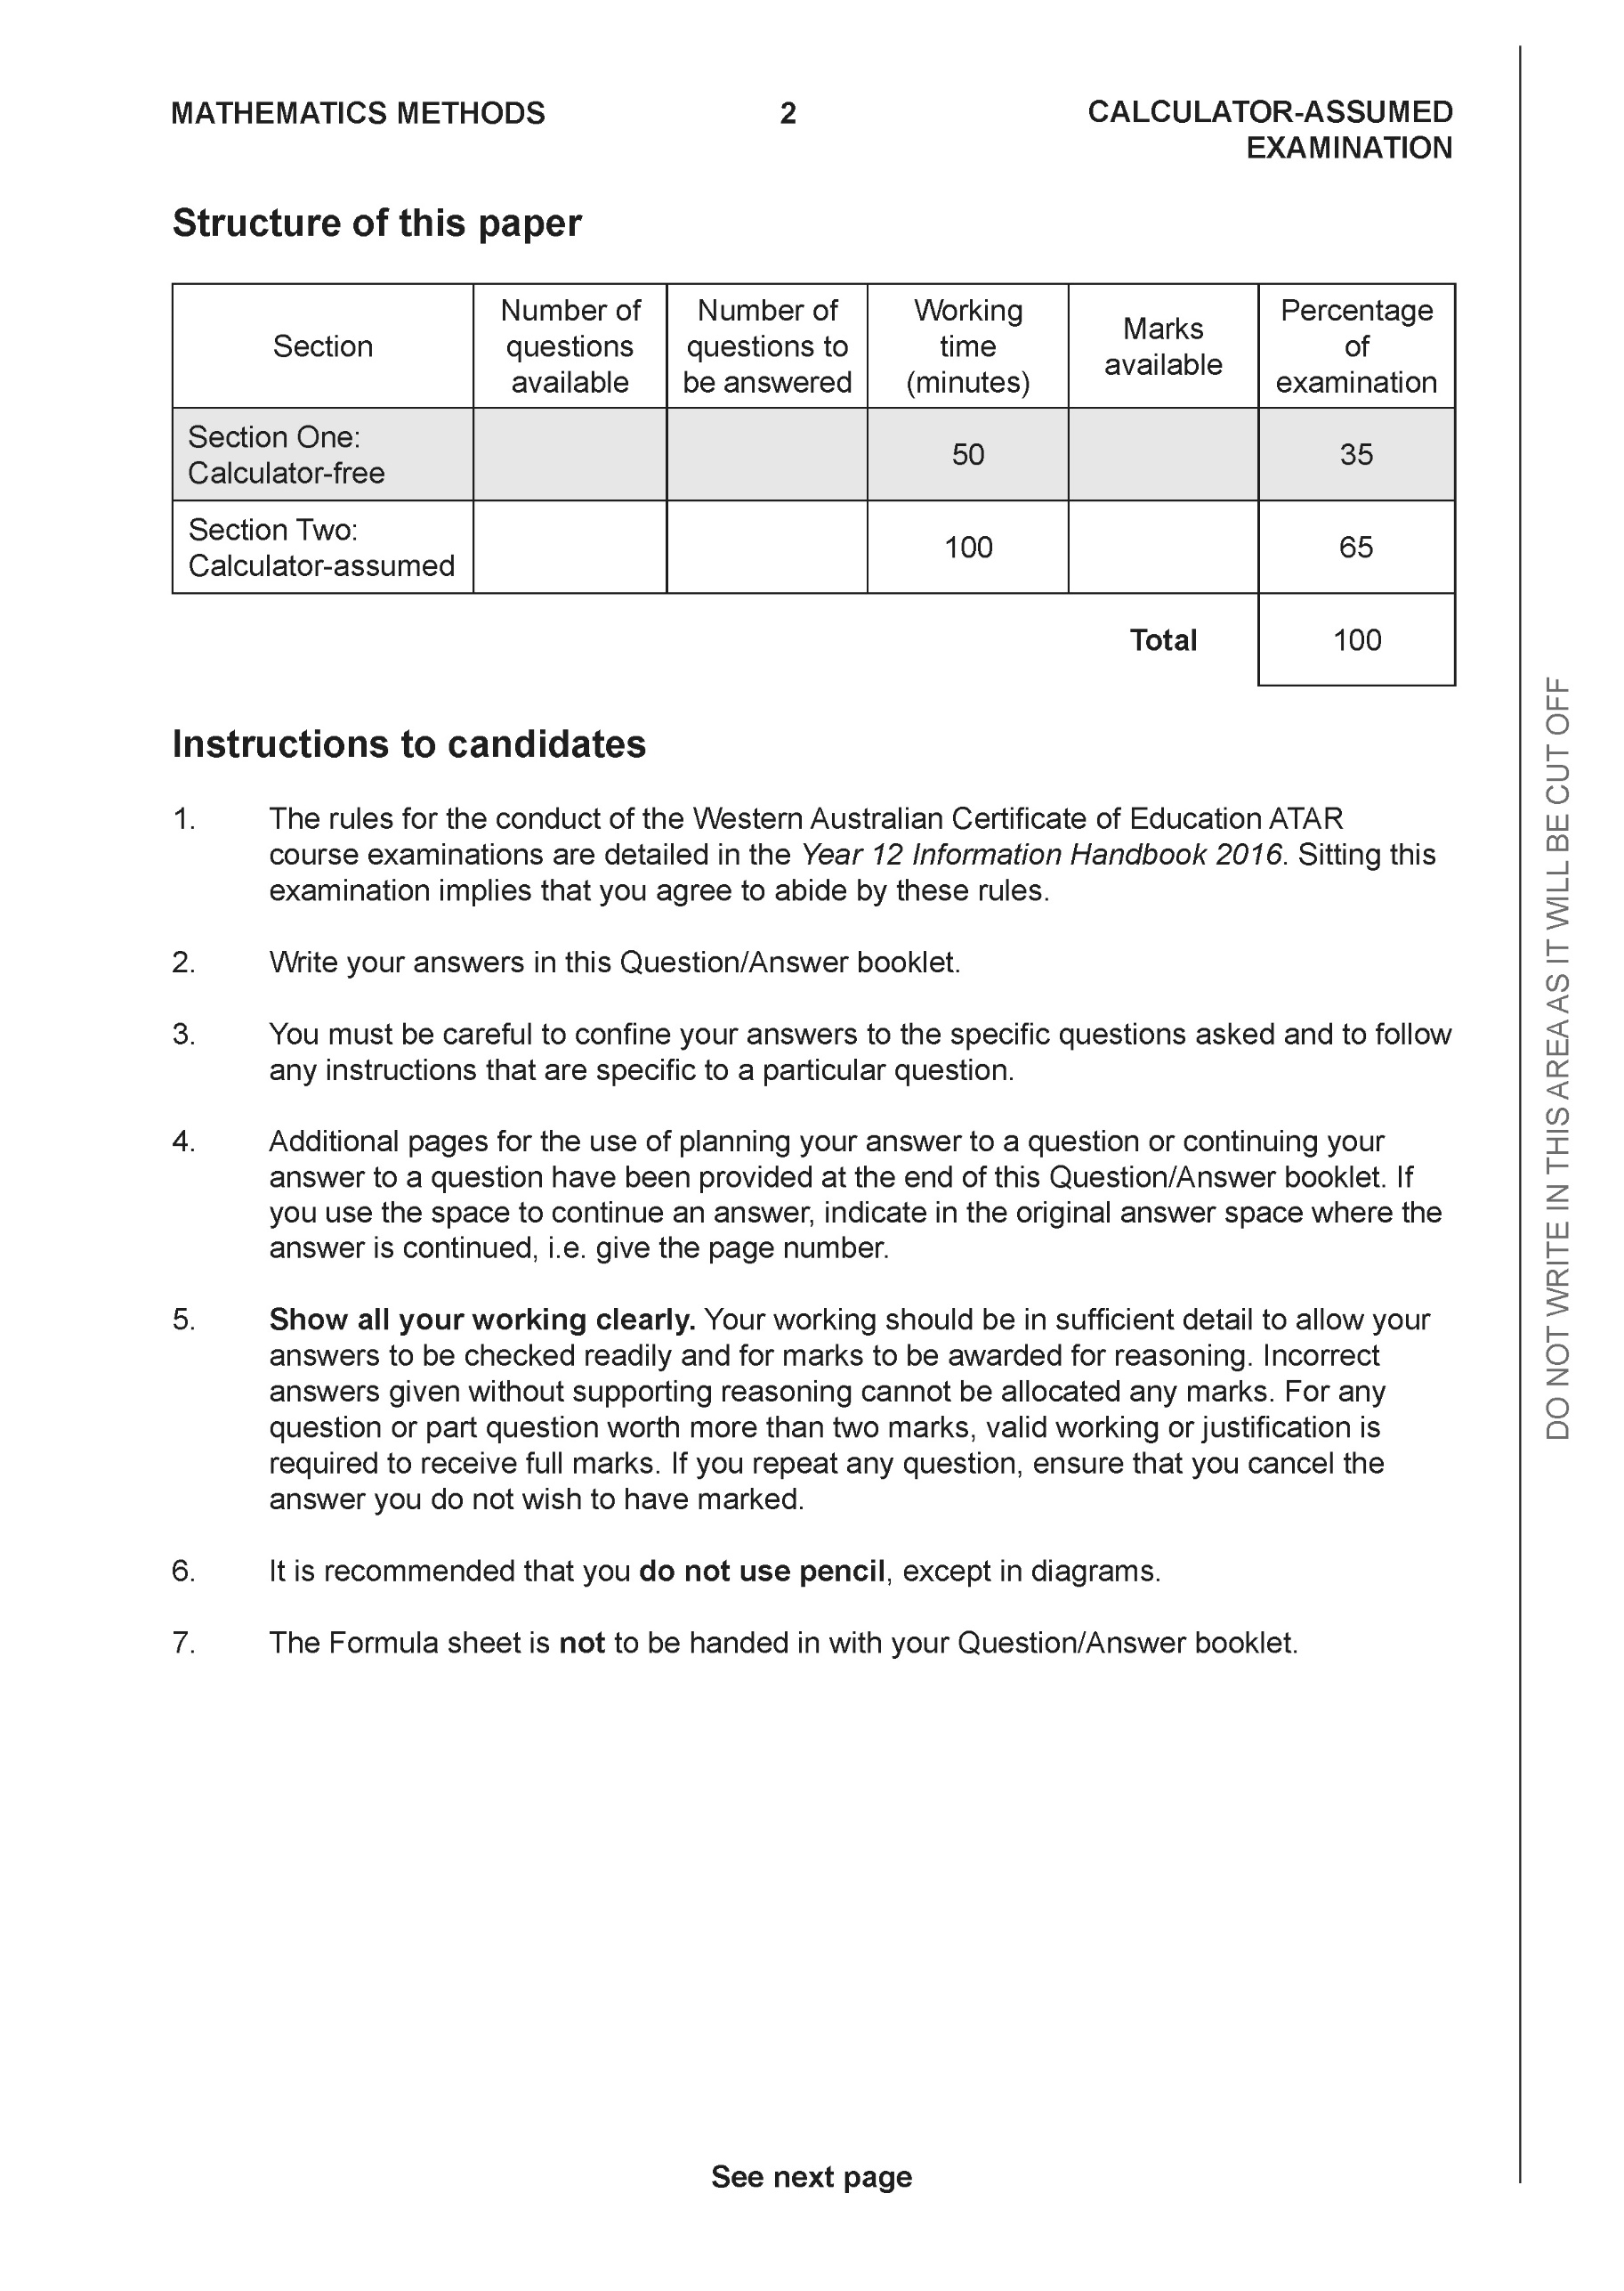

Section Two: Calculator-assumed (98 Marks)

This section has 11 questions. Answer all questions. Write your answers in the spaces provided.

Spare pages are included at the end of this booklet. They can be used for planning your responses and/or as additional space if required to continue an answer.
● Planning: If you use the spare pages for planning, indicate this clearly at the top of the page.
● Continuing an answer: If you need to use the space to continue an answer, indicate in the original answer space where the answer is continued, i.e. give the page number. Fill in the number of the question that you are continuing to answer at the top of the page.

Working time: 100 minutes.

Question 8 (5 marks)
Consider the following system of linear equations with are constants.
Determine all the values of such that:
- There will be an unique solution
- There will be infinite solutions
- There will be no solutions

Solution
Specific behaviours
eliminates one variable from two equations
eliminates two variables from one equation
states values for unique
states values for infinite
states values for no solution
Question 9 (8 marks)
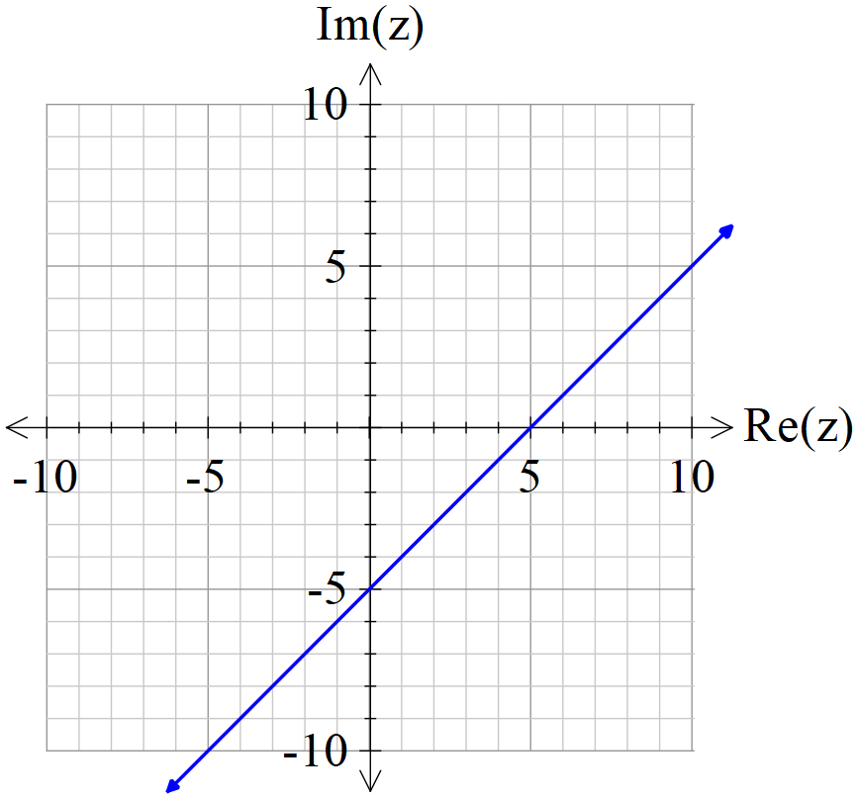

Consider the locus of which is drawn above.

- If the locus above can be defined by , determine the constants
. (2 marks)

Solution
Specific behaviours
states a
states b

- Determine the exact minimum value of on the locus above. (3 marks)

Solution
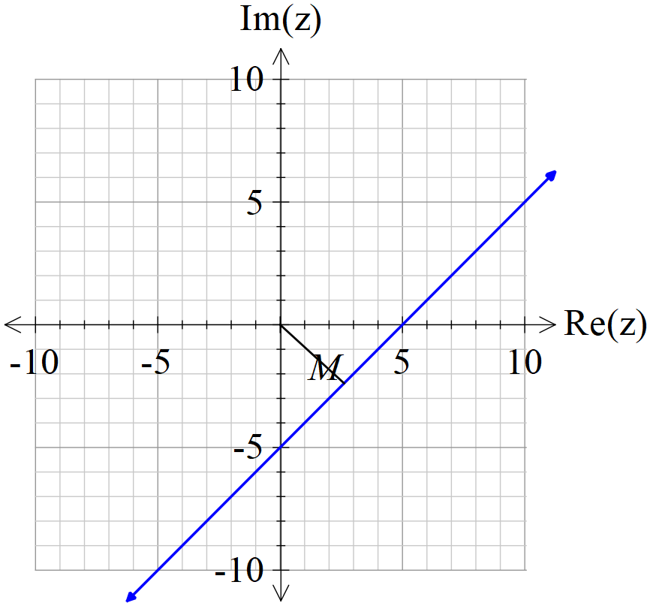
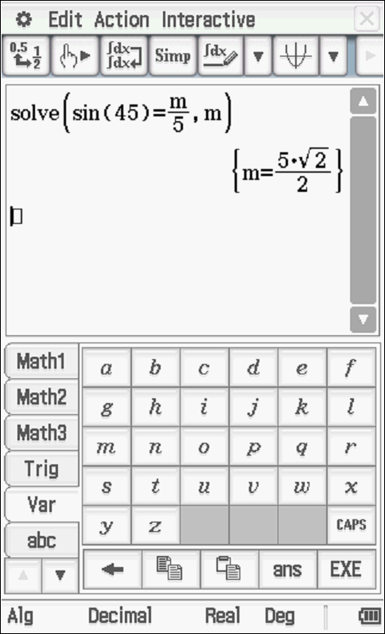

Specific behaviours
uses perpendicular through origin
sets up equation
solves for exact minimum

- Sketch the new locus of on the axes above showing major features.
(3 marks)
Solution
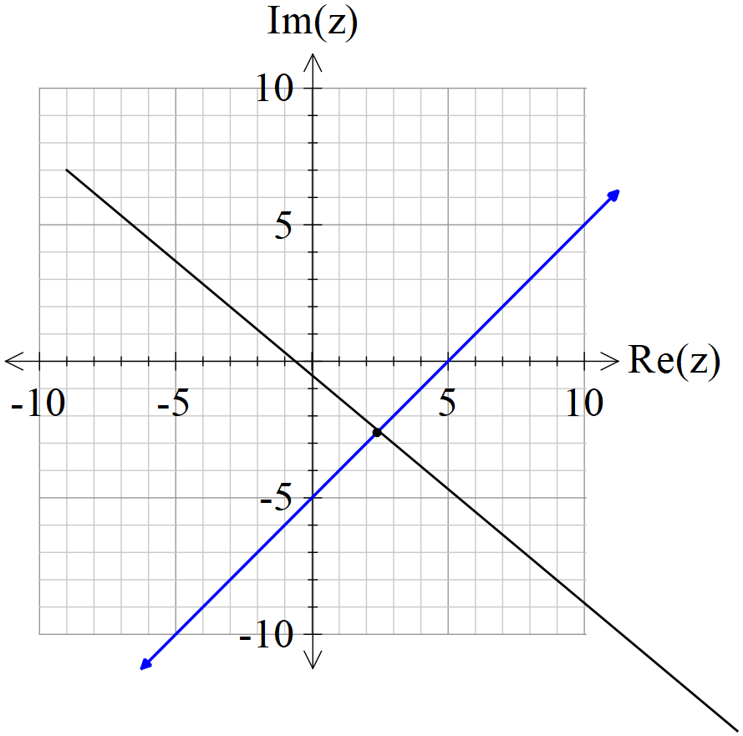

Specific behaviours
uses midpoint of 5 & -5i
draws line
line is perpendicular (angle labelled)

Question 10 (10 marks)

Let .

(a) Express the complex number in polar form using the principal argument in radians.
(2 marks)

Solution
Specific behaviours
determines modulus
determines principal argument

The complex number is drawn in the complex plane as shown below.

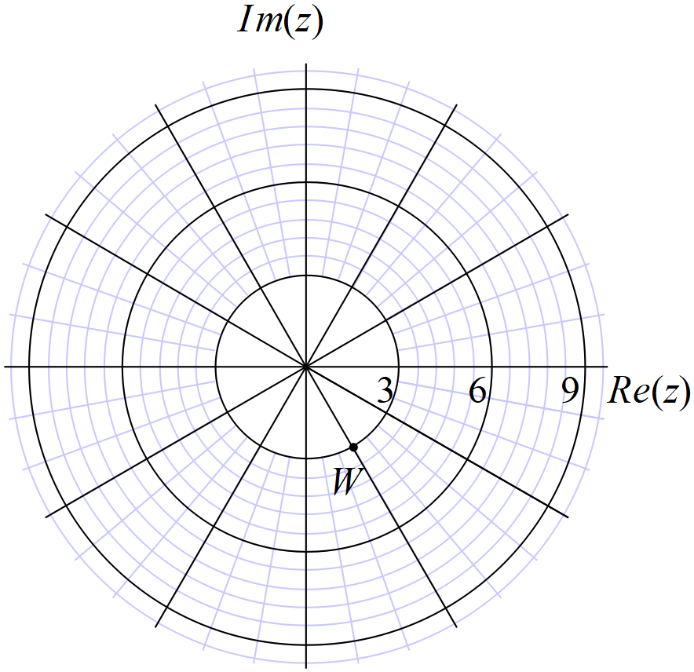

(b) Express the complex number in polar form using the principal argument (2 marks)

Solution
Specific behaviours
determines modulus
determines principal argument

(c) Plot on the axes above, the complex numbers . (4 marks)

Solution
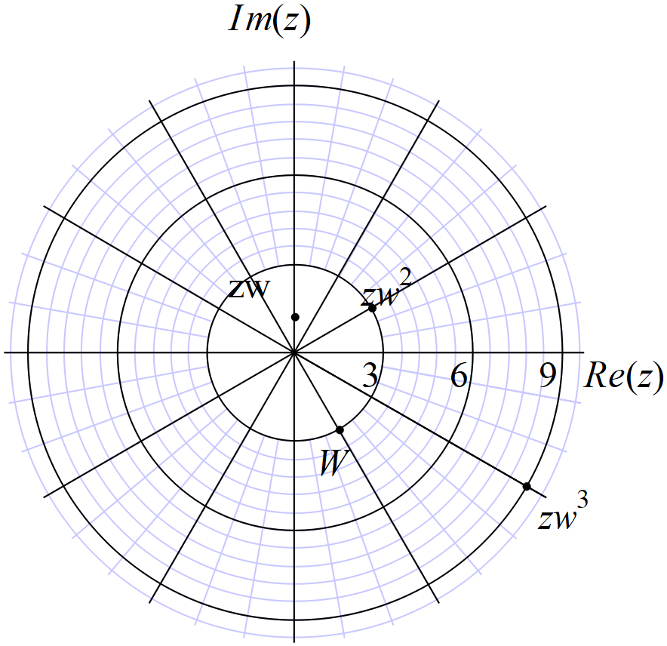

Specific behaviours
zw plotted
plotted
plotted
argument changes by same amount

(d) Explain geometrically the transformation effect of multiplying by . (2 marks)

Solution
Angle decreases by 60 degrees or
Modulus increase by factor of three

Specific behaviours
describes effect on argument
describes effect on modulus

Question 11 (9 marks)
Consider the plane .
(a) Determine the vector equation of a line that passes through Point A and is perpendicular to the plane above. (2 marks)
Solution
Specific behaviours
uses normal vector
states vector equation

(b) Hence or otherwise, determine the distance of point A from the plane above. (3 marks)

Solution
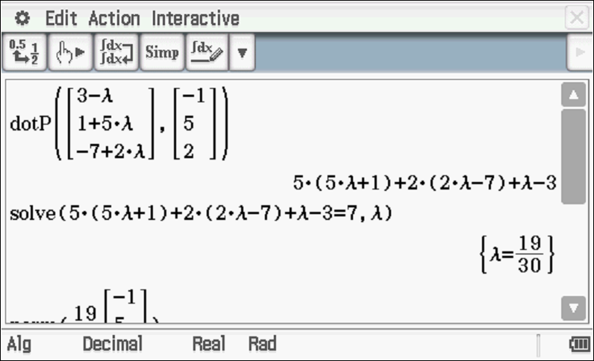

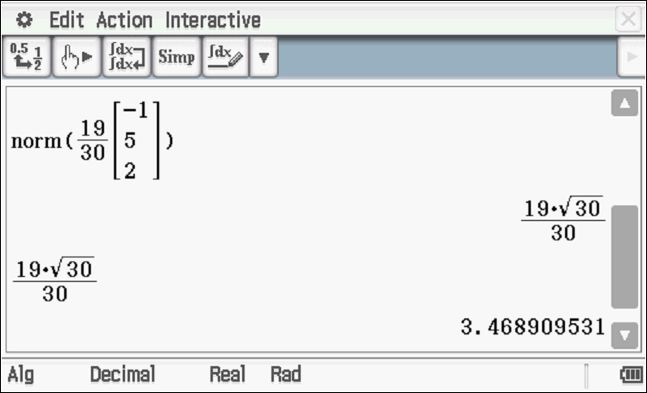
Specific behaviours
subs r from line into plane
solves for parameter
solves for distance

Alternative solution

Solution
Choose any point on plane (0,0,7/2)
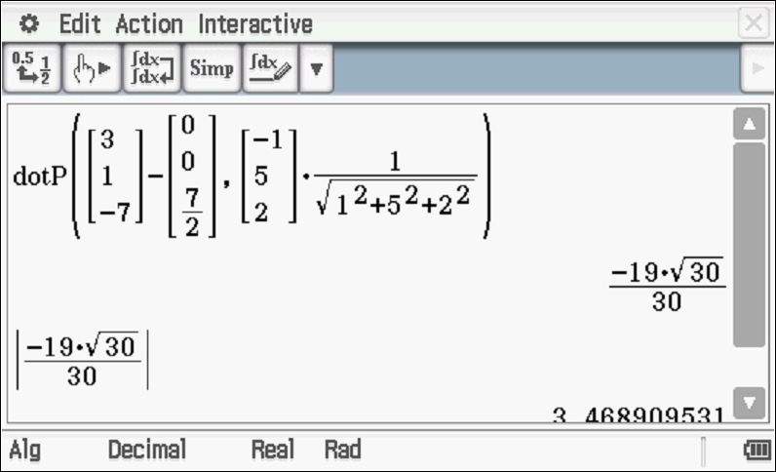

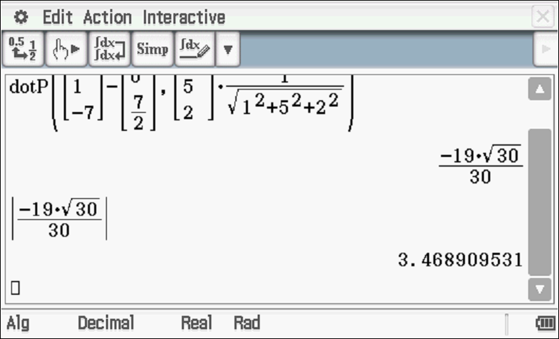
Specific behaviours
determines any point on plane
dots vector between tow points with unit normal
determines approx. distance(no need to round)

(c) Consider the sphere where is a real constant. Determine the value(s) of so that the line is a tangent to the sphere. (4 marks)

Solution
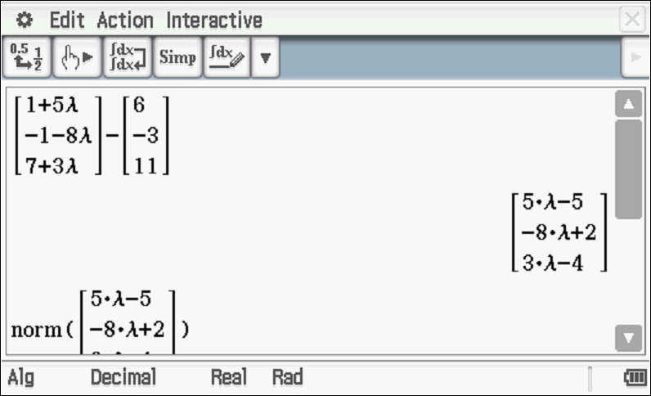
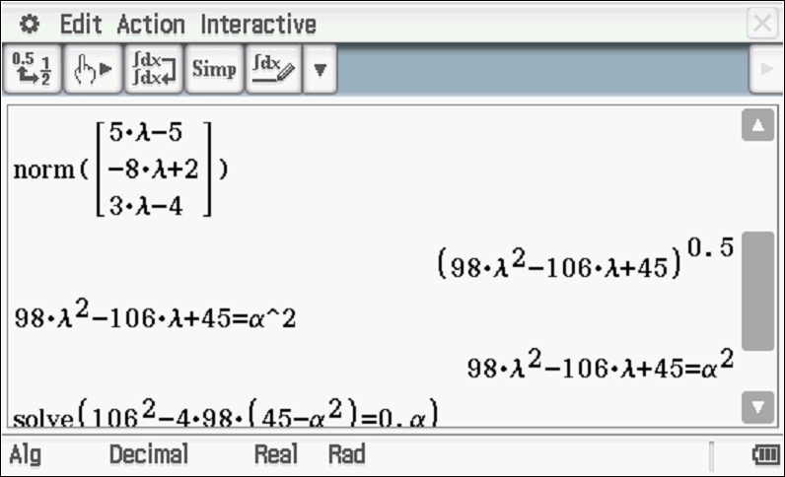

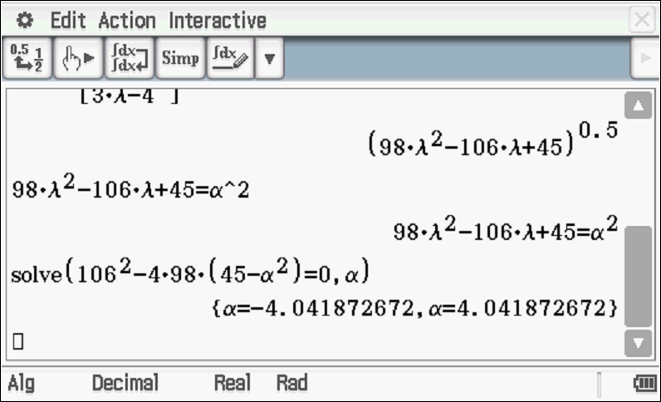

Alpha = 4.04 only
Specific behaviours
subs line into plane equation
sets up an equation for alpha using magnitude of vector
equated discriminant of quadratic to zero
states one positive value for alpha to two decimal places (needs to discard negative value)

Question 12 (12 marks)

Consider the plane shown below with the following points .

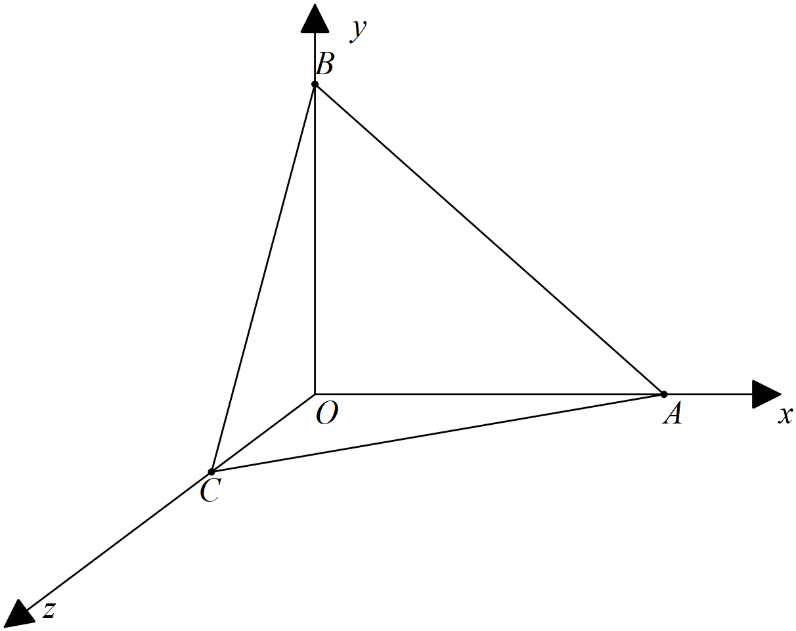

Let be the midpoints of respectively.

(a) Determine the position vectors (2 marks)

Solution
Specific behaviours
States OM vector
States ON vector

(b) Using vector methods, show that trisect each other, that is divide each other in the ratio . (4 marks)

Solution
Let P divide BM in ratio 2:1
Let Q divide CN in ratio 2:1

Specific behaviours
defines two points on both line segments with ratio
shows how to define position vector of one point
shows how to define other independently
shows that both vectors are equal hence same point

(c) Determine using vector methods, the area of the face (3 marks)

Solution
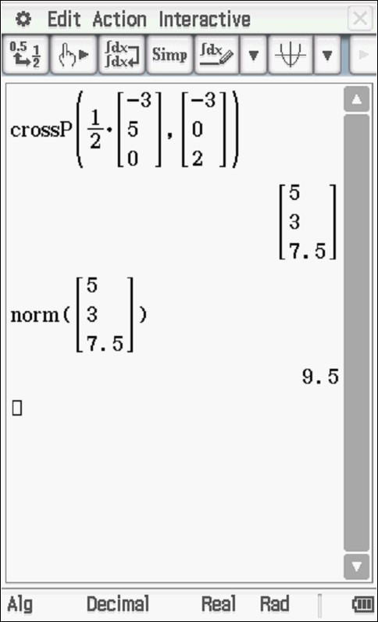

Specific behaviours
uses vectors in method
states a correct expression for area
states area

(d) Determine the cartesian equation of the plane . (3 marks)

Solution
is a normal

Specific behaviours
determines normal vector
derives vector equation
converts to cartesian

Question 13 (5 marks)

Consider the plane , which is parallel to a second plane . Given that point is a point on plane , determine the distance of point from the plane to two decimal places.

Solution
Choose any point on first plane (0,0,3)

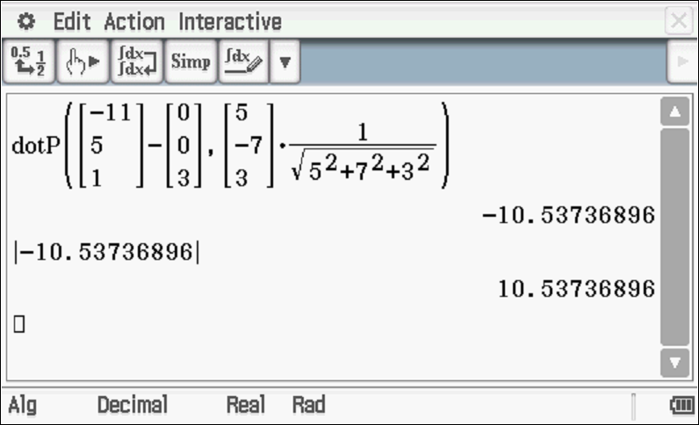

Distance = 10.54 units
Specific behaviours
chooses any point on first plane
Vector subtracts points on either plane
dots with normal
using unit normal
determines distance to two decimal places

Question 14 (9 marks)

Particle A started to move with constant velocity at 11:30am, at 1pm the particle was at position .

(a) Determine the position of particle A at 11:30am. (2 marks)

Solution
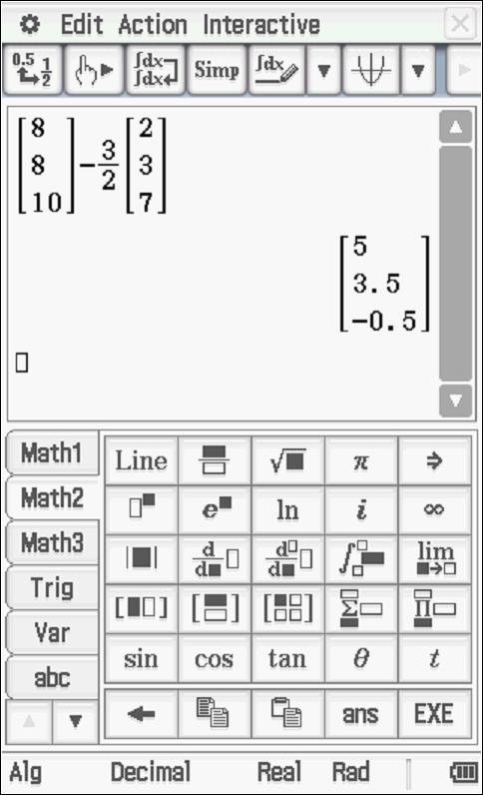

Specific behaviours
uses subtraction with t=1.5
states position vector

Particle B left at 1pm, moving with constant velocity .
(b) Determine the distance between the two particles at 2pm that day. (3 marks)

Solution
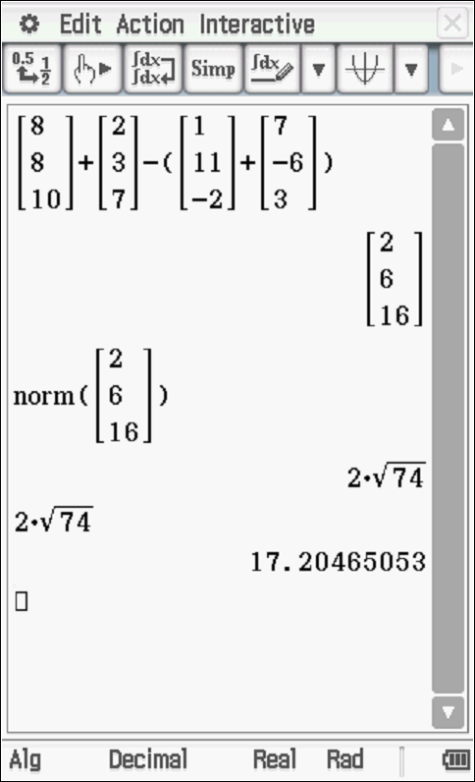

Specific behaviours
determines positions of both particles
uses vector difference of points
determines approx. distance (no need for units)

(c) Determine the closest distance between the two particles if they maintain their constant velocities and the time it occurs. (two decimal places) (4 marks)

Solution
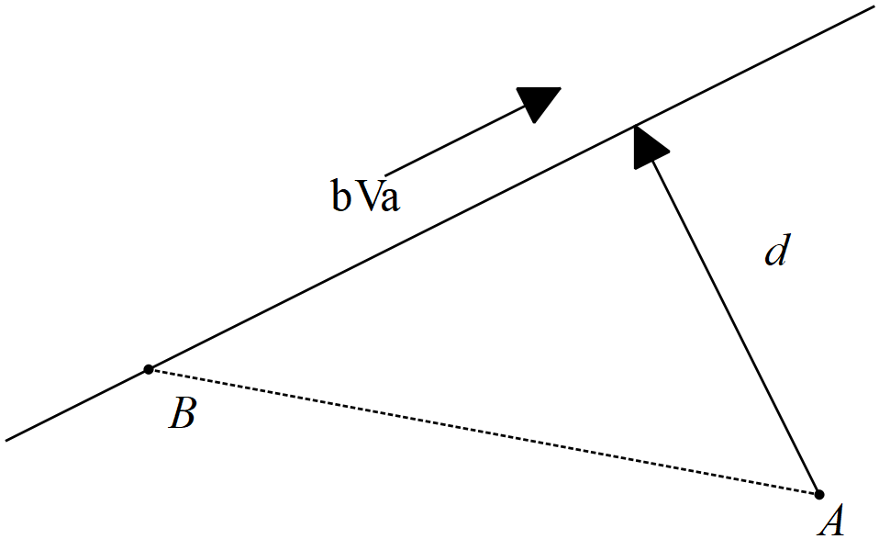

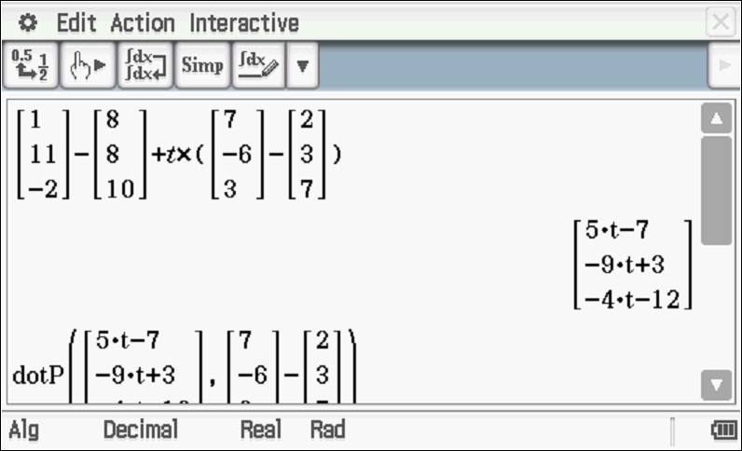
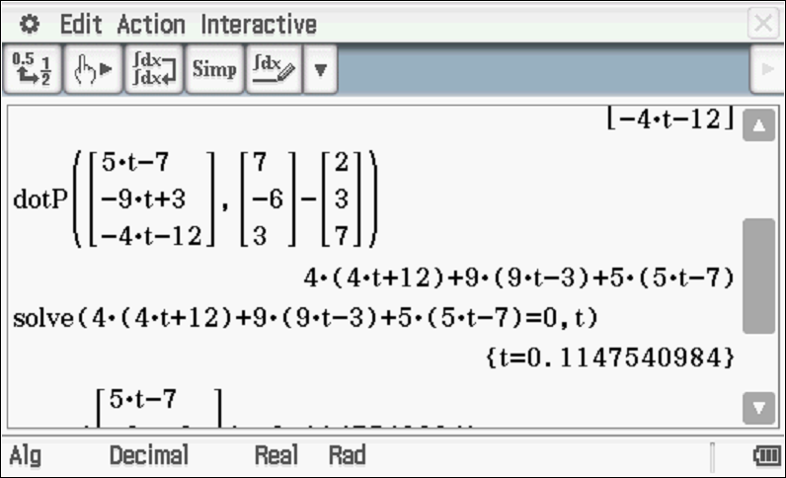
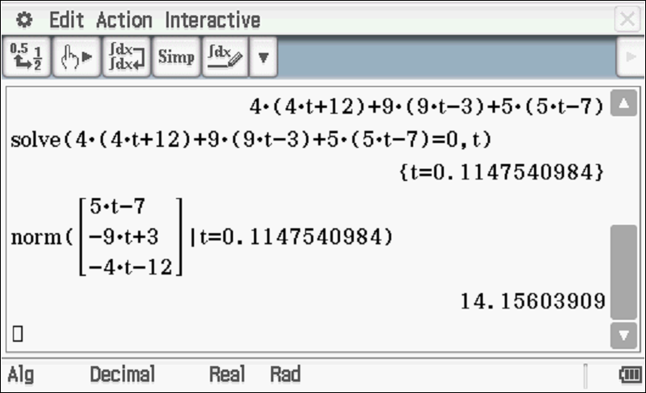
Specific behaviours
determines expression for displacement vector d
uses relative velocity
uses dot product and solves for t from 1pm
determines approx. distance, no need to round, no units
Alternative solution
Solution
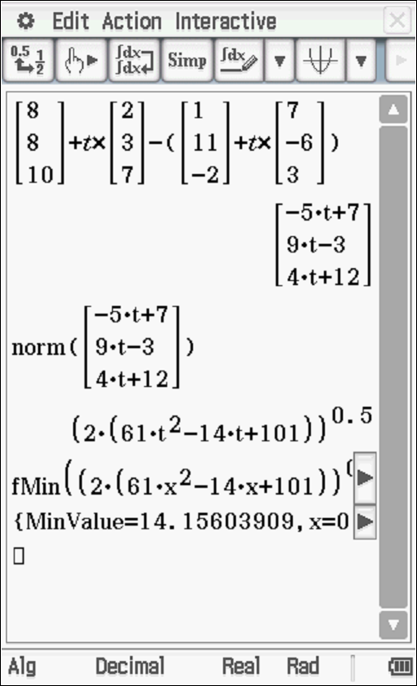

Specific behaviours
obtains expression for difference in position vectors
subtracts and determines magnitude
minimizes expression via calculus/graph/CAS
states approx. distance, no need to round nor units

Question 15 (8 marks)
A particle moves with acceleration at time seconds.
Initially the particle is at the origin with velocity

(a) Determine the velocity function at time seconds. (2 marks)

Solution
Specific behaviours
integrates
solves for vector constant

(b) Determine the first two times that the particle is moving parallel to the x axis. (3 marks)
(2 decimal places)

Solution
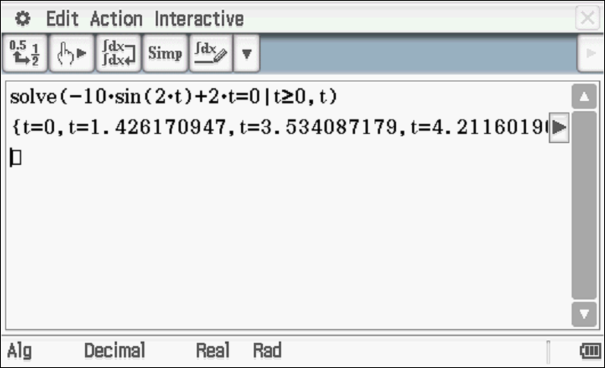
Times 0 seconds and 1.43 seconds

Specific behaviours
equates y component of velocity to zero
solves for non negative t values
at least one time value rounded to two decimal places

(c) Determine the exact distance of the particle from the origin at time seconds.
(3 marks)

Solution
Specific behaviours
integrates to find position vector
solves for vector constant
determines exact magnitude of r at required time

Question 16 (10 marks)

Consider the following motion defined by at time seconds.

(a) Describe the motion. (2 marks)

Solution
Circular motion with radius 3 m, angular speed 2 rad/sec

Specific behaviours
gives at least one correct description
gives at least two

(b) Determine the initial velocity and acceleration. (3 marks)

Solution
Specific behaviours
uses calculus to find velocity and acceleration
states initial velocity
states initial acceleration

(c) Determine the time(s) that the velocity is perpendicular to the acceleration. Justify.
(3 marks)

Solution
Specific behaviours
uses dot product with velocity and acceleration
obtains un-simplified expression
shows that simplifies to zero for all values of t

(d) Determine the exact distance travelled in the first 10 seconds. (2 marks)

Solution
Specific behaviours
shows that speed is 6 m/s
states distance with units

Question 17 (12 marks)

At midday two rockets, A & B were observed moving in the sky above moving with constant velocities. Their positions and velocities were recorded as below at midday. They appear to have been moving for a number of hours and will continue to do so for many more.

Let = number of hours from midday.

(a) Determine for Rocket A, the position vector from the origin at time hours. (2 marks)

Solution
Specific behaviours
uses velocity and t
states position vector

(b) Determine the cartesian equation for the path of Rocket A. (2 marks)

Solution
Specific behaviours
states parametric equations
states cartesian equation( no need for parameter)

(c) Show that the rockets will not collide after midday. (2 marks)

Solution
-4*x+4

Specific behaviours
solves for t for one dimension
solves for another dimension and shows different solution

(d) Determine the times after midday that the rockets are less than 60 km apart.
(3 marks)

Solution
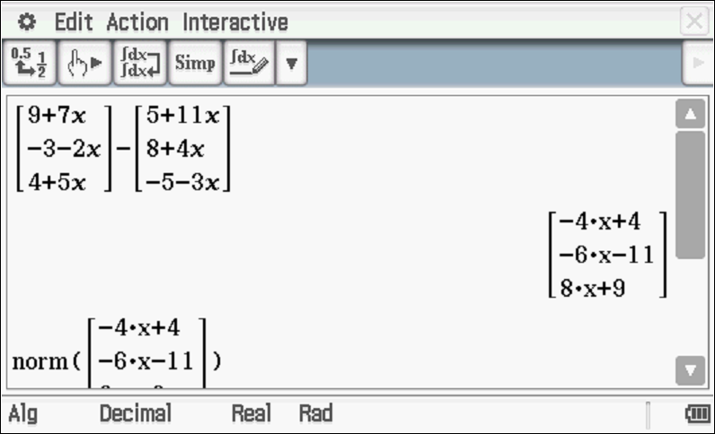
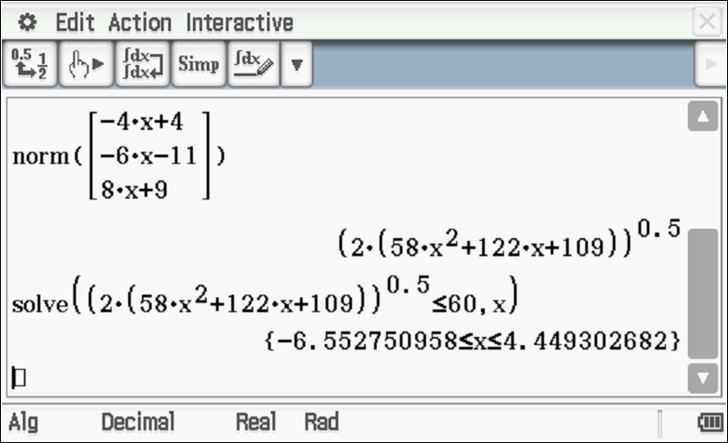
Time lass than 4.5 hours after midday

Specific behaviours
obtains expression for displacement apart at x hours
determines distance apart at x hours
solves for positive values less than 4.50 hours

(e) Determine the closest approach from midday and the time that this occurs.
(3 marks)

Solution
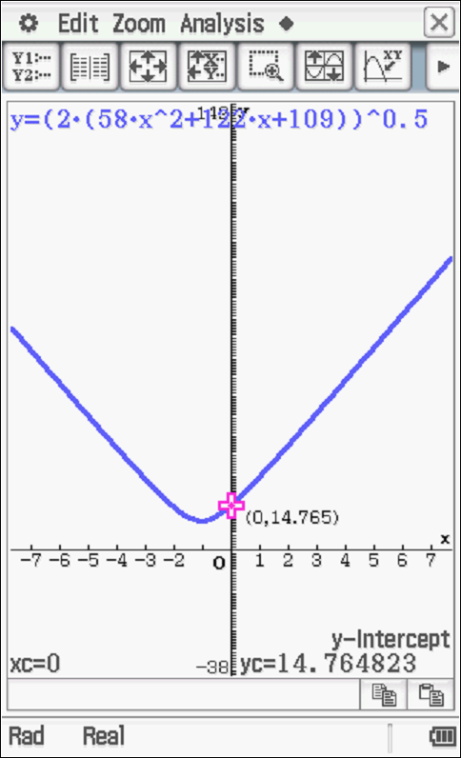

Closest approach at midday, t=0, at 14.765 km

Specific behaviours
graphs expression for distance apart at x hours or uses calculus
only accepts non negative values of x
states time and distance, no need to round nor units

Question 18 (10 marks)
Consider a tennis ball moving with velocity that hits a surface with a normal vector of as shown in the diagram below.
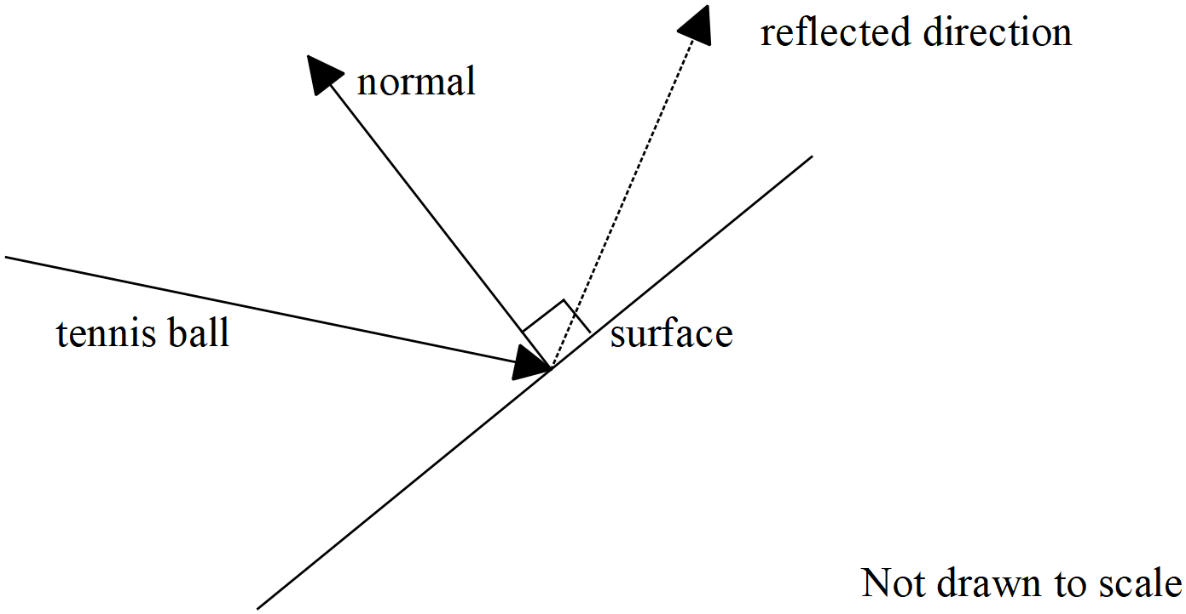

(a) Determine the angle between the velocity vector and the normal vector to two decimal places in degrees. (2 marks)

Solution
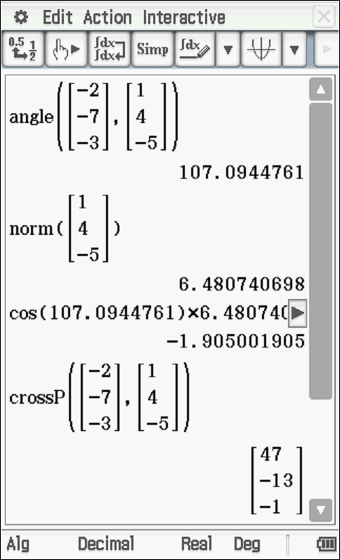

Specific behaviours
uses acute or obtuse angle between the two lines in radians or degrees
states obtuse angle between vectors

Let the unit vector be parallel to the reflected direction of the tennis ball. This vector is in the same plane as the velocity and normal vectors above.

(b) Given that the tennis ball is reflected such that the angle with the normal equals that of the incident acute angle with the normal. Show that when rounded to three decimal places. (3 marks)

Solution
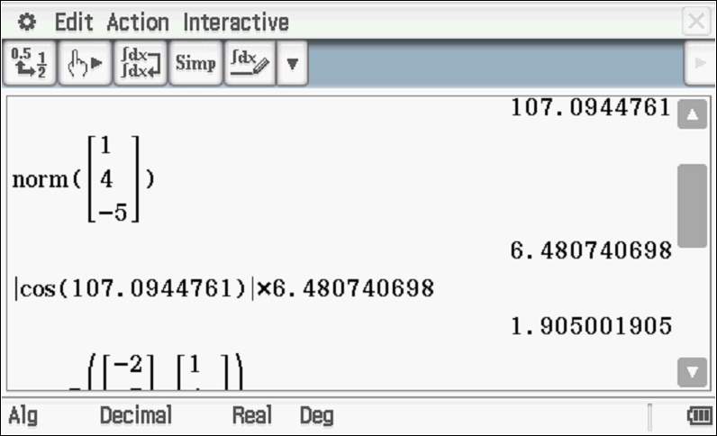
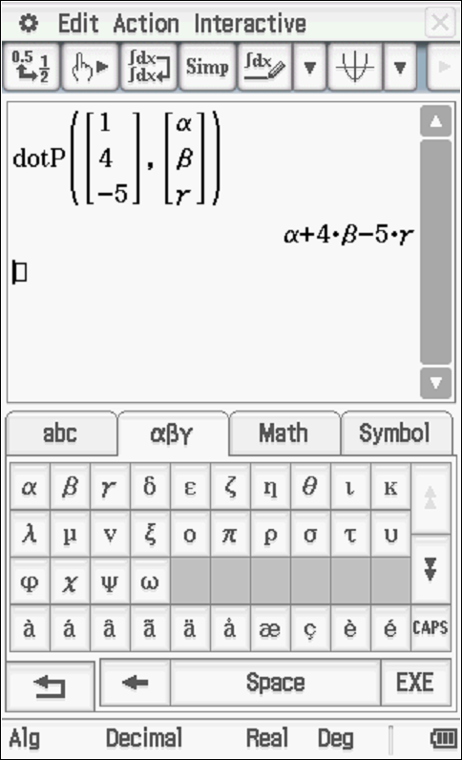

Specific behaviours
uses dot product
uses acute angle
shows the derivation of linear equation (no need to round)

Q18 continue-

(c) Derive another two independent equations for . (3 marks)

Solution
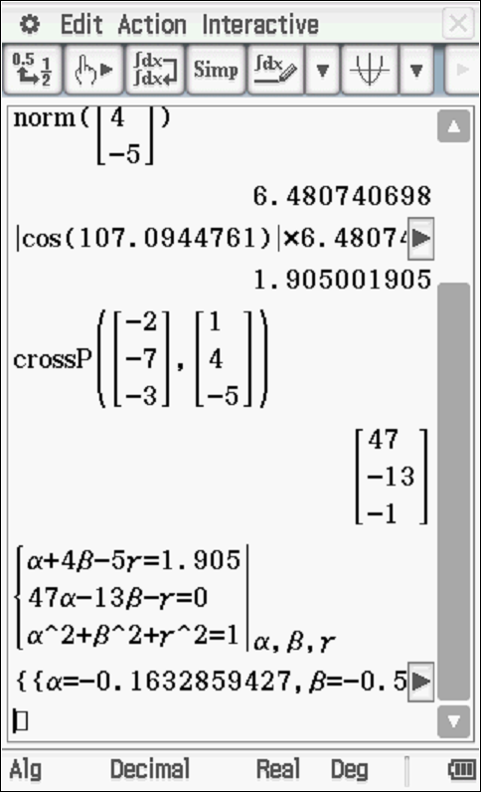
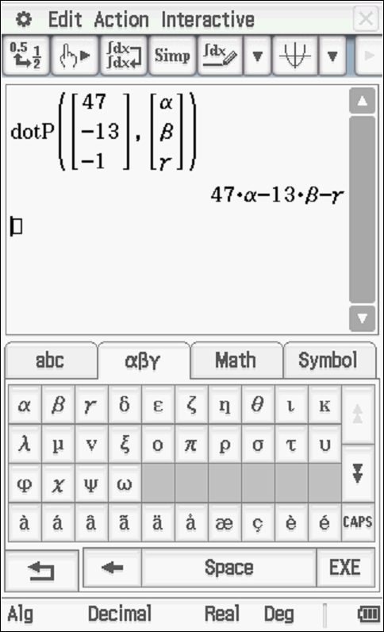
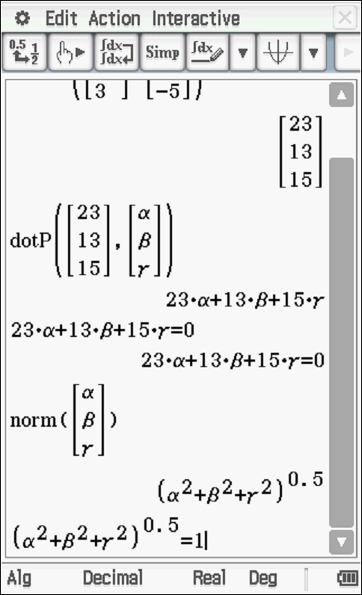

Specific behaviours
uses cross product
shows derivation of one equation
shows derivation of both equations

(e) Solve for to two decimal places. (2 marks)

Solution
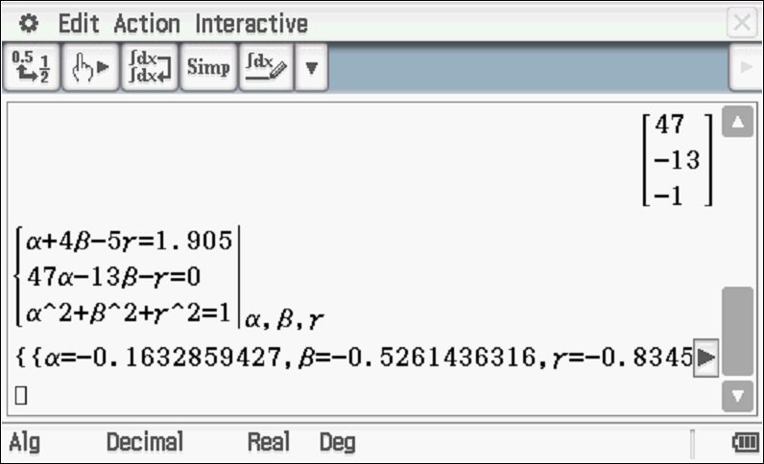

Specific behaviours
solves for one unknown
solves for all three, no need to round

Working out space

Working out space

